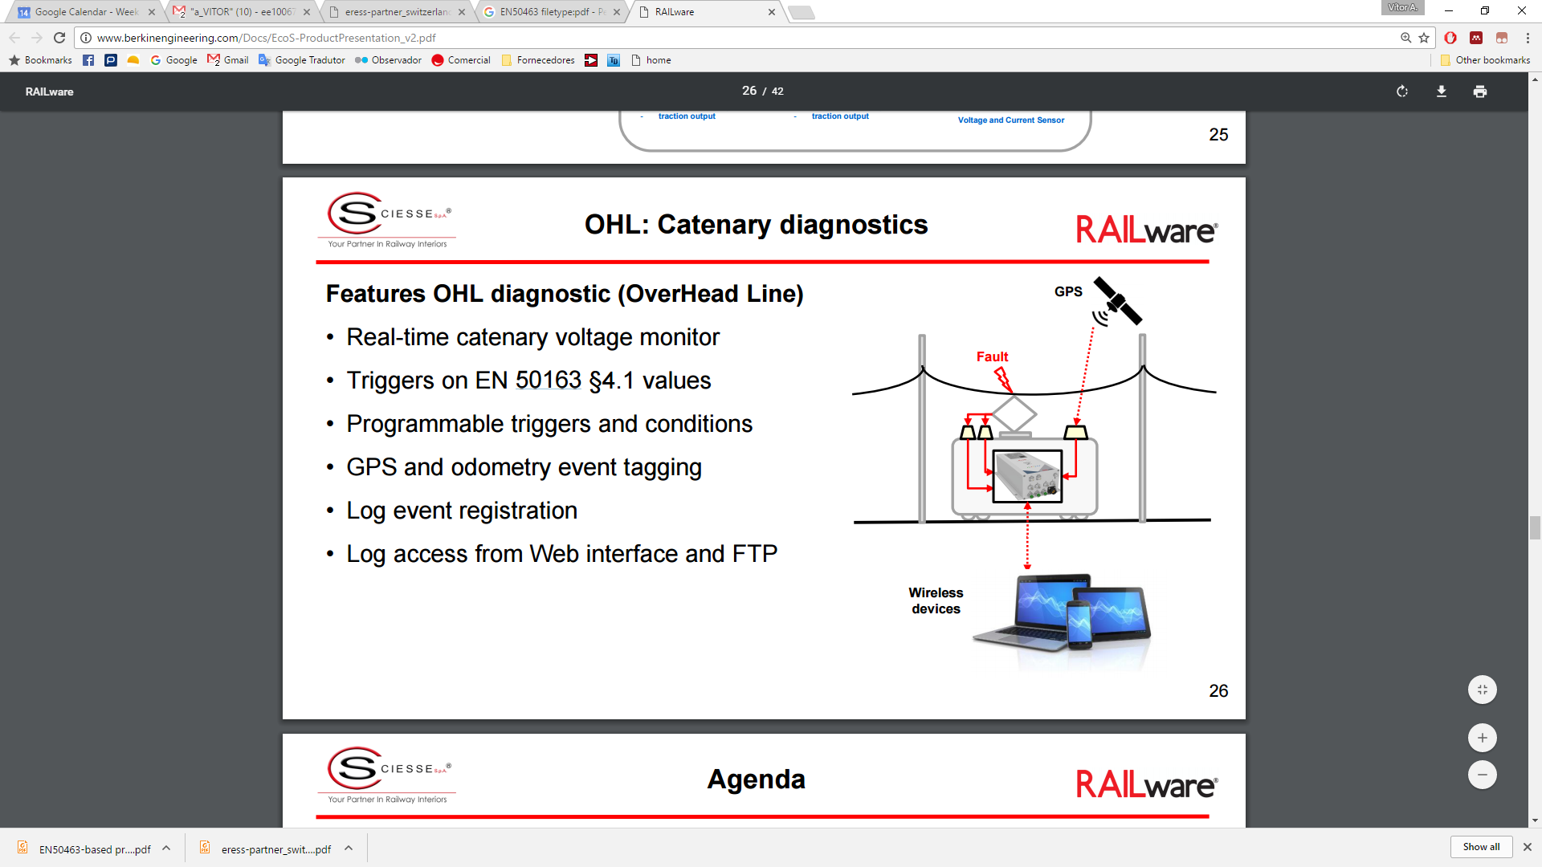

<http://www.berkinengineering.com/Docs/EcoS-ProductPresentation_v2.pdf>